Guidance to identify and support young people involved in Criminal Exploitaiton
Guidance document for Further Education.
April 2021

Contents list
Introduction 2
What is Child Criminal Exploitation? 6
What is Child Sexual Exploitation? 7
What is County Lines? 8
Contextual Safeguarding 9
Toolkit A - Risk factors 9
Toolkit B - Warning Signs and Key Indicators 11
Toolkit C - Risks to Exploited Young People 12
Toolkit D - Offences 12
Toolkit E - Guidance on Event Recording 14
Toolkit F - Interventions 16
Toolkit G - An example of a CCE assessment toolkit. 17
Toolkit H - Safer searching for staff and students. 25
Case Study (1) 30
Case Study (2) 31
Tips for responding to exploitation 32
Resources 33

Scope of the document: Enabling a whole FE College Community to engage in a partnership approach that reconsiders how violence is fundamentally viewed, prevented, and managed at primary, secondary and tertiary stages of development. *

*Primary – Programs targeted at the entire population in order to provide support and education before the problems occur.
Secondary – Programs targeted at communities in need to alleviate identified problems and prevent escalation.
Tertiary – Programs to provide interventions for those affected.

A definition of Child Criminal Exploitation: Children who have been forced to undertake illegal activities by gangs or individuals should not be criminalised. They must be recognised as victims and given appropriate support which priorities their safety, recovery, and future outcomes. (Barnardo's Recommendations)

“When someone you trust makes you commit a crime for their benefit” – D-aged 12.

Introduction
This protocol and the guidance within this document are for the use of all Further Education (FE) College Staff; they are to be used when a young person is suspected of being involved in crime through exploitation (CCE).
This document has been created to enable Further Education Institutions to have a consistent approach when dealing with students who are being criminally exploited. They may be witness to, or subject to violent crime and this guidance will allow you to support the young person by understanding of the legal requirements around this.
Students who are being coerced or forced to commit crime and especially violent crime should be considered as victims – in a criminal justice setting they will be treated as suspects, until there is evidence of exploitation and then they will be treated as victims, but staff should treat them as victims from the start.
It is expected that a multi-agency wrap around approach, involving partners including Children’s Services, Adult Services, Police, Youth Justice, Education and Children’s Charitable services should be implemented to support the understanding of the young person and their family, community and peers. This will be subjective to the commissioned services in the relevant Borough and the age of the student. Importantly, this list is not exhaustive, the creative use and inclusion of partners and agencies must always be considered and if appropriate altered, at every stage.
The approach in this document will enable the early identification of suitable interventions to disrupt the student's current behaviour patterns and influence positive change.
All children and young people are vulnerable to exploitation. Potentially this is more so, when the student has previously been subjected to Adverse Childhood Experiences (ACE's), as the effects of toxic stress and trauma on a Young Person can severely increase risk taking behaviour.
Similarly, where there are documented concerns around Young People who are suffering with their mental health, even when low or moderate, rendering them vulnerable to exploitation and risk-taking behaviours.
Agencies, locally and nationally, do not yet fully understand the scale or level of risk to children and young people from exploitation. Family-focused services are not always appropriate for dealing with the exploitation of children outside of a family setting – agencies need to be flexible and respond quickly to changing risks.
Within this document you will find the following:
- Process Map
- What is Child Criminal Exploitation?
- What Is Child Sexual Exploitation?
- What is County Lines?
- Toolkit A – Risk Factors
- Toolkit B – Warning Signs / Key Indicators
- Toolkit C – Risks to Exploited Young People
- Toolkit D – Offences
- Toolkit E – Guidance to Event Recording
- Toolkit F – Interventions
This document is designed to provide guidance and it should sit alongside your policies and procedures relating to Safeguarding, Managed Moves and Exclusions.
Colour and shape | Meaning
Green Rectangle | College Action
Cyan Rectangle | Toolkits
Teal shaded Rectangle | Title statement
Blue Rectangle | Multi-agency approach, all parties have a responsibility to support the school in making a decision regarding the child’s welfare

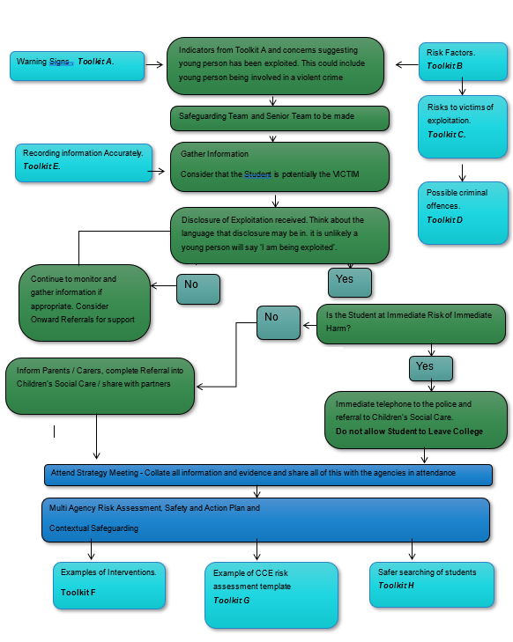

Remove weapon safely and store safely until collected by Police. See Toolkit C
Contact Police 999 or 101. See NPCC when to ring police and Legislation guidance. Toolkit D &H

What is Child Criminal Exploitation?
Child Criminal Exploitation (CCE) occurs where an individual or group takes advantage of an imbalance of power to coerce, control, manipulate or deceive a child or young person under the age of 18 into any criminal activity;
(a) In exchange for something the victim needs or wants, and/or
(b) For the financial or other advantage of the perpetrator or facilitator and/or
(c) Through violence or the threat of violence. The victim may have been criminally exploited even if the activity appears consensual. Child Criminal Exploitation does not always involve physical contact; it can also occur through the use of technology.”
Children are groomed through fear, threats and intimidation or by being befriended and receiving gifts or financial rewards. They can find themselves trapped, controlled and forced to engage in criminal activity such as theft, trafficking drugs on behalf of their abusers and carrying weapons. These forms of exploitation have been linked to recent increases in knife crime in major cities as well as smaller towns.
Sexual abuse can be used as a powerful tool to exert power and control over young people. In some cases the stigma and shame associated with this abuse is used as a form of blackmail to coerce vulnerable young people into criminal activity. (Barnardo's)

Below is an example of a grooming line which was created by young people to demonstrate the process of grooming.
- 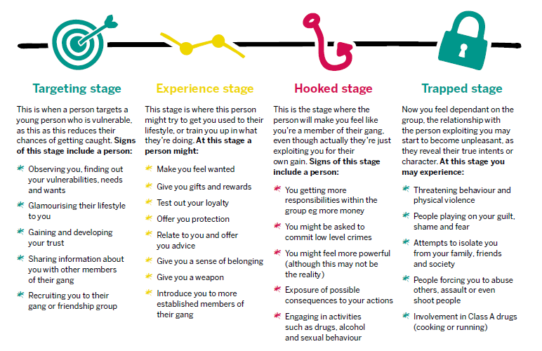
When working with young people it is important to consider peer on peer exploitation. It is common that young people that have been exploited are often coerced into grooming and exploiting other young people.

Exploitation often involves cuckooing; cuckooing is where a gang and/or drug dealers will take over a property usually of someone vulnerable and use it as a base for criminal activity. We are seeing an increased number of young people being found in cuckooed properties.

What is Child Sexual Exploitation?
CSE stands for child sexual exploitation and is a type of abuse. It’s when children or young people under the age of 18 are tricked into performing sexual acts. It can happen to both boys and girls. However, in an FE setting disclosures may be received which are historic and the victim is now over 18. Victims in these cases will be treated as adults.
At the start, the young person may think they’re in a loving consensual relationship, because they get gifts, money, status, affection. In reality, they are being groomed.
Having gained the child’s trust, abusers can control them through threats and violence. They may force them to have sex with other people and even make them groom other young people for sex.

What is County Lines?
County lines is a form of criminal exploitation, in which criminals groom and manipulate children or young people into drug dealing, often in towns outside their home county.
A serious problem in the UK, its name comes from the mobile phone 'lines' that are used to control where the young person goes to deliver drugs.
It is important that practitioners working with young people and vulnerable adults understand what county lines is so that they can identify those at risk or involved in county lines exploitation and know what action to take.
County lines is the common denominator in a range of exploitative situations including; drug dealing, violence, gangs, modern slavery and missing persons. The concerted efforts of a range of departments, agencies and organisations are needed to tackle it.
The UK Government definitions of county lines and Child Criminal Exploitation (CCE) are: “County lines is a term used to describe gangs and organised criminal networks involved in exporting illegal drugs into one or more importing areas [within the UK], using dedicated mobile phone lines or other form of “deal line"
They are likely to exploit children and vulnerable adults to move [and store] the drugs and money and they will often use coercion, intimidation, violence (including sexual violence) and weapons.
County Lines is also intrinsically linked to Child Sexual Exploitation. Gangs involved in Criminally exploiting Young People and Children, will often sexually exploit them or other Children or Young People.

Contextual Safeguarding
Exploitation is contextual safeguarding issue, this meaning that it considers extra-familial harm. Extra familial harm means harm that happens outside the home.
- 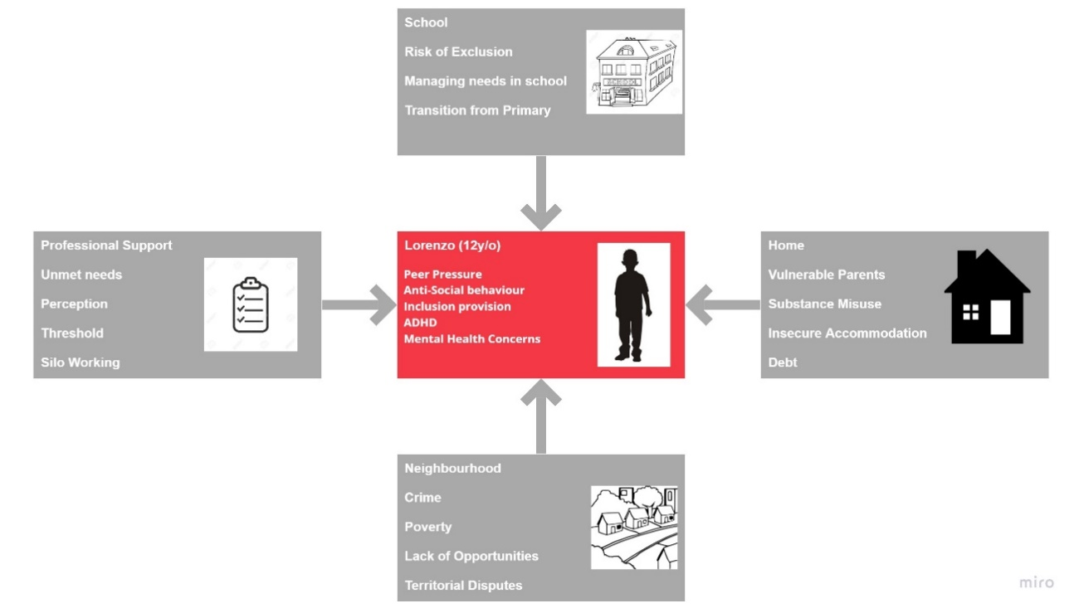
The above diagram demonstrates contextual safeguarding. This shows how different contexts can contribute to vulnerabilties and make young people at risk of exploitation. Contextual safeguardings means wokring across agencies to support young people at risk.
For more information on contextual safeguarding please visit: Contextual Safeguarding Website

Toolkit A - Risk factors
Push / Pull factors
Children and Young People will become susceptible to CCE / CSE (Child Sexual Exploitation) for several reasons. The list is not exhaustive.
Push factors are reasons why a young person; does not want to remain in college, is unhappy or unsettled at home.
Pull factors are those enticing or grooming factors that bring the young person into the exploitative and dangerous situation:
Push Factors
- Family Conflict
- Parental Separation
- Domestic Abuse in the home
- Neglect
- Physical, Emotional or Sexual Abuse
- Parental Substance Misuse
- Mental Health Concerns
- Issues with their care placement
- Adverse Childhood Experiences
Pull Factors
- Criminal Exploitation (including county lines)
- Sexual Exploitation
- Negative Peer Relationships
- Anti-Social Behaviour
- Substance Misuse
- Parties/Gatherings
- Visiting Family away from placement
Additionally, there is research to show that there are risk factors aligned to education and home status, which leave Young People with an increased vulnerability to exploitation:
- Children who are Looked After
- 16/ 17-year olds living in supported / semi-independent accommodation
- School Exclusion
- Alternative Provision
- Special Educational Needs
- Mental Health Problems – especially when receiving no support
- Young carers
Where multiple risk factors come together the risk for exploitation increases and is more likely.
It is imperative for Colleges to be aware of, keep up to date with and document all Safeguarding Concerns – whatever the perceived level.
We must ensure that a broad picture and overall understanding of the student is available.
Early identification of students with the above, particularly multiple factors can be targeted for early intervention and support.
It would be useful for Colleges to reference this within their current Safeguarding Policies, Mental Health and Wellbeing Policies.

Toolkit B - Warning Signs and Key Indicators
Signs that a young person may be involved in Criminal or Sexual Exploitation can include:
- Missing from home
- Absent from college
- Returning home late
- Attending late, leaving early in college
- Unexplained money
- Unexplained phones / multiple phones (classically a Nokia brick phone)
- New clothes and/or jewellery
- Being secretive about who they are talking to and where they are going
- Signs of drug use
- Increasing disruptive or aggressive behaviour
- Involvement in Anti-Social Behaviour
- Use of drug related, violent or sexual language
- Young Person arrested in possession of a knife or illegal drugs (most likely crack cocaine or Heroin)
- Unexplained injuries
- Unexplained association with young adults
- Arrested in possession of unexplained quantities of cash
- Change in demeanour
- Rapid decrease in school performance
- Unexpected use of alcohol or drugs
- Parents seeking help from Professional Agencies
Where multiple Key Indicators are evident the risk that the young person is being exploited is greater.
It would be useful for Colleges to reference this within their current Safeguarding Policies, and Mental Health and Wellbeing Policies.

Toolkit C - Risks to Exploited Young People
Young people who have been or are being exploited may have experienced or be at risk of the following:
- Physical injuries: risk of serious violence and death.
- Emotional and psychological trauma.
- Sexual violence: sexual assault, rape, indecent images being taken and shared as part of initiation/revenge/punishment, internally inserting drugs.
- Debt bondage - young person and families being ‘in debt’ to the exploiters; which is used to control the young person.
- Neglect and basic needs not being met.
- Living in unclean, dangerous and/or unhygienic environments.
- Tiredness and sleep deprivation: child is expected to carry out criminal activities over long periods and through the night.
- Poor attendance and/or attainment at College

Toolkit D - Offences
Once a young person is groomed it is difficult for them to break away from the gang / offenders, and the level, regularity and types of crime can quickly increase. In some cases the young person will not identify as being part of a gang.
Types of Crime a Young Person may be forced to commit:
- Holding or Carrying firearms for an Organised Crime Group/Gang (OCG)
- Using firearms or knives which would include shooting and causing violence to others. This would include grievous bodily harm with intent, grievous bodily harm, actual bodily harm or common assault. You may her terms like Sect 18, 20, 47 and 39 - these relate to those assault offences.
- Supplying, sourcing controlled substances. There are lots of controlled substances and they are given a Class by the Home Office - A, B and C. Class A is considered the most dangerous and would include drugs such as Heroin, and Crack Cocaine.
Class B would include Cannabis, Codeine, Synthetic Cannabinoids and
Class C would include Ketamine and Steroids.
- Involvement in planned harm to others, which includes luring a person to an area where they will be harmed.
- Conspiracy to commit and commit burglaries
- Damage of community or properties
- Personal robbery with or without a weapon.
- Car robbery

Toolkit E - Guidance on Event Recording
This document is useful in developing a practice within colleges of asking the right kind of questions to ensure the appropriate action is taken.
The person the information is reported to may not be the person ringing the police or contacting the safeguarding lead in the Local Authority, so it is important the information is recorded accurately.
In the case where a student or member of staff reports an event it is crucial that a written record begins at the earliest opportunity. This record will ensure that when information is disseminated between members of staff the information is accurate.
Remember, it is very likely that this information will lead to action. Is the action necessary and proportionate in the circumstances?
Also remember that the young person may not see or recognise themselves as a victim or may be unable or too embarrassed to explain what is happening.
Additionally, they may not trust or believe that you are able to help them out of the situation as the threat to them may feel too high. Therefore, it is important to consider other avenues to gather information such as peer groups or family members.
Consider using open questions;
What? Where? When? Who? Why? and How?.
It is important to test the accuracy (provenance) of the information. If a student tells a member of staff that another pupil has been involved in an offence or a student disclosed they have it’s useful information but further questions to ascertain how they know this; where did this happen; why do they believe it is happening; how did they find out makes the information more valuable and will lead to a greater confidence in dealing with the event.
Where a member of staff suspects a student has possession of any illegal substances or weapons then they should refer to set college policies to search, seize and retain as appropriate, but remember that the student in the first instance should be treated as a victim. If the student has any injuries, then medical attentions should be sought. If and when the action is questioned or shared the member of staff and the College should be confident that their decision making was structured and informed.
The National Decision-making model provides a framework to help you make informed choices based on the information you have and behavioural policies with your establishment.
Fig A. The National Decision-Making model. (NDM)
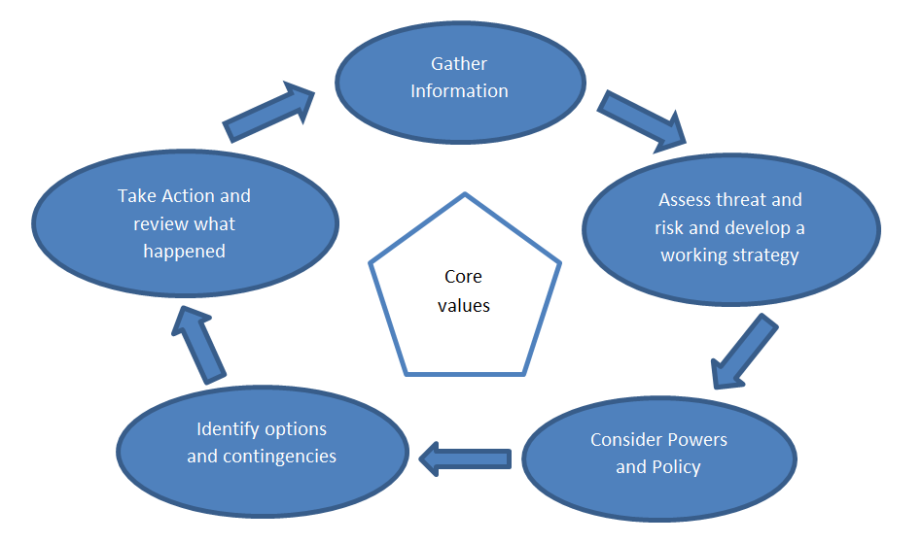
There is a real balance between the necessity for speed in taking action and taking enough time to be sure about the details of the event. It is critical to ask the right questions at the earliest opportunity to build provenance around an event.

Toolkit F - Interventions
The earlier the intervention the more likely it is to be successful – single or a combination of the below are worth consideration at all stages; in order of when?
- Support with Speech and language
- Educational Health Care Plan
- Support with Special Educational Needs
- Raising awareness of students – allow students to discuss their experiences (Values for Living?)
- Training for staff – work with all staff so that they can pick up the signs as well as understanding the risk factors and indicators
- Mentors in College (MVP)
- Work with parents more closely – how can students be supported in the Community?
- Connect with the Students, provide safe and secure environment for them to discuss and disclose
- Understand the importance of timely sharing information
- Create good relationships with other agencies to share information
- Advocate for the student – ensure their perspective is maintained, understand past trauma
- Refer into Children’s Social Care – LA to make decision re National Referral Mechanism- NRM guidance as one of the toolkits?? Advocating for young people
BUILD A RELATIONSHIP WITH THE STUDENT / MONITOR THE STUDENT / KEEP THEM SAFE

Toolkit G - An example of a CCE assessment toolkit.
Child Criminal Exploitation Assessment
(Trigger factors which may indicate that your student is being Criminally or Sexually Exploited)
The below Matrix is a lift from Project Phoenix and a Tool used by Multi Agency Partners in combination to understand the risk that a Young Person may be of being Criminally or Sexually Exploited. This Tool is also useful for Professionals in Education to evaluate if a Young Person is at risk and could be completed alone or in collaboration with a combination of other Professionals within the college setting, other Professionals you are working with, the Young Person and / or their Parent or Carer.
The assessment Tool will provide you with an indication of the level of risk the Young Person is at, and evidence to share with other Partners such as the Police and / or Children’s Social Care, in combination with other Toolkits and considerations which are provided within this pack.
The matrix also provides a useful framework for discussion and consideration when dealing with Young People who you have concerns about and are wondering what may be happening to them.
- Missing episodes
- College attendance
- Misuse of substances
- Parent / Carer – Young Person Relationship
- Accommodation
- Ability to Identify Abusive / Exploitative Behaviour
- Engagement with Appropriate Services
- Sexual Health
- Association with Risky Peers / Adults
- Social Media (internet, mobile etc.)
Total
Professional Judgement Score
Overall Score (Total from 10 indicators above plus professional judgement score)

1a |  | Episodes of Missing from Home / Care
 | 0 | Has never been missing from Home / Care - (Score 0)
 | 1 | Stays out later than they should but, but rarely goes missing – (Score 1)
 | 2 | Occasionally goes missing (short OR prolonged period of time) – (Score 2)
 | 3 | Frequently goes missing but usually for short periods of time – (Score 3)
 | 4 | Frequently goes missing for prolonged periods of time – (Score 4)
1b |  | Assessors Reflections and Observations

2a |  | Current Education Situation
 | 0 | Engages well in college - (Score 0)
 | 1 | Is engaged in college but attendance or stability is a concern – (Score 1)
 | 2 | Is on a reduced timetable at college, or is persistently absent – (Score 2)
 | 3 | Is excluded from college but shows an interest in finding a suitable place – (Score 3)
 | 4 | Excluded from college– (Score 4)
2b |  | Assessors Reflections and Observations
3a |  | Misuse of Substances
 | 0 | No concerns - (Score 0)
 | 1 | Some concerns about drugs or alcohol – (Score 1)
 | 2 | Use of drugs or alcohol is concerning – (Score 2)
 | 3 | Alcohol and/or drug dependency is suspected – (Score 3)
 | 4 | Clear evidence of drugs / alcohol dependency – (Score 4)
3b |  | Assessors Reflections and Observations

4a |  | Relationship with Parent / Carer
 | 0 | Positive relationship with parent / carer with effective communication. Evidence of emotional warmth and stability in the home. Responds well to boundaries - (Score 0)
 | 1 | Relationship with parent / carer is generally positive. Boundaries are in place but the young person does not always adhere to them – (Score 1)
 | 2 | Relationship with parent / carer is strained or there has been a recent negative change in the quality of the relationship – (Score 2)
 | 3 | Historic abuse in the family (emotional, neglect, physical or sexual) OR negative change in the quality of the relationship – (Score 3)
 | 4 | Ongoing abuse in the family OR poor communication, low warmth, attachment or trust. Parent / carer does not implement age appropriate boundaries – (Score 4)
4b |  | Assessors Reflections and Observations

5a |  | Accommodation
 | 0 | Accommodation meets the young person’s needs and is a stable place where they feel secure- (Score 0)
 | 1 | Accommodation is generally satisfactory but with some concerns about longer term stability – (Score 1)
 | 2 | Accommodation is unsuitable / unstable / unsatisfactory or placement has recently changed – (Score 2)
 | 3 | Accommodation is very unstable / there have been several recent placement changes – (Score 3)
 | 4 | Is homeless or in temporary accomodation – (Score 4)
5b |  | Assessors Reflections and Observations

6a |  | Ability to identify abusive / exploitative behaviour
 | 0 | Has a good understanding of exploitation / abuse and can use it to keep themselves safe - (Score 0)
 | 1 | Reasonable understanding of abuse / exploitation – (Score 1)
 | 2 | Some understanding of abuse / exploitation. Can recognise risks but does not apply this in practice to stay safe – (Score 2)
 | 3 | Very limited recognition of abuse / exploitation – (Score 3)
 | 4 | No recognition of what constitutes abuse / exploitation – (Score 4)
6b |  | Assessors Reflections and Observations

7a |  | Engagement with appropriate services
 | 0 | Good engagement with all appropriate services - (Score 0)
 | 1 | Good engagement with a single service but less so with others – (Score 1)
 | 2 | Some engagement with services, occasional contact – (Score 2)
 | 3 | Contact with services is sporadic and / or inconsistent – (Score 3)
 | 4 | Poor or no engagement with services– (Score 4)
7b |  | Assessors Reflections and Observations

8a |  | Sexual Health
 | 0 | No concerns / is not sexually active - (Score 0)
 | 1 | Sexually active in an equal consensual relationship with a peer. Does not feel pressured to have sex – (Score 1)
 | 2 | Some sexual health concerns / is feeling pressure to have sex – (Score 2)
 | 3 | Sexually active and has poor sexual health awareness– (Score 3)
 | 4 | Sexually active in an inappropriate relationship, due to their age or the age of he sexual partner / sex in non-consensual. tested for STI’s or pregnancy– (Score 4)
8b |  | Assessors Reflections and Observations

9a |  | Association with risky Peers / Adults
 | 0 | No concerns - (Score 0)
 | 1 | Aware of local gang activity or similar risks but not actively involved – (Score 1)
 | 2 | Socialises with vulnerable peers or peers who may pose a risk – (Score 2)
 | 3 | In contact with adults who may pose a risk – (Score 3)
 | 4 | Regularly associates with risky adults / peers or is actively involved in gangs – (Score 4)
9b |  | Assessors Reflections and Observations

10a |  | Internet and Social Media Use
 | 0 | Good awareness of online dangers, with suitable parental controls in place - (Score 0)
 | 1 | Has links with or is friends with unknown people via social media / internet – (Score 1)
 | 2 | Involved with secretive / unmonitored use of internet, including via a mobile phone. Sometimes receives texts or contacts from unknown people – (Score 2)
 | 3 | Shares inappropriate messages or images online and does not appear to ne aware of he online dangers – (Score 3)
 | 4 | Has met people after talking to them online, regularly shares inappropriate images and / or messages, sometimes with strangers, including adults – (Score 4)
10b |  | Assessors Reflections and Observations

Wishes and Feelings of the Young Person
(Wherever possible and safe it is useful to gain the perspective of the Young Person. How do they feel? What is happening in their life? Do they feel at risk? Do they need support?

Toolkit H - Safer searching for staff and students.
Some considerations for the safer searching of students.
Each Education site will have its own procedures around scanning and searching and their use of the powers under the Further and Higher Education Act.
Whether the college has a policy of searching all students as a condition of entry, an agreement that a specific student is to be searched on a daily basis or searching based on specific information, there are some safer techniques that can be considered.
Fig A. Search Wand
There are several brands of wands available. Most operate by emitting a sound when they detect metal. Some can be used on silent and will vibrate rather than making a sound.
The wands are a good means of confirming suspicion and they do so in a manner that avoids physical contact between the designated member of staff and student.
There are several brands of wands available. Most operate by emitting a sound when they detect metal. Some can be used on silent and will vibrate rather than making a sound.
The wands are a good means of confirming suspicion and they do so in a manner that avoids physical contact between the designated member of staff and student.
Communication strategy prior to and during search
Conversation between student and staff should always remain professional. Your intention is to search the young person/adult and it is important to have a no surprise approach. You may want to consider approaching the conversation in the following manner.
Think of the acronym GOWISE
G State your Grounds for search; be confident in your powers under the Further and Higher Education Act. If you have a written record as per Appendix A you will understand the value of the information.
O Tell the pupil what the Object of the search is – you may be concerned of a blade they may be concerned about something else in their bag
W Consider What position you hold in the college and how that affects your power -are you designated?
I your Identity; the student may know you but they may not.
S Search, tell them how you are going to search them. Reassure them that their dignity and safety is paramount
E Everything you do should be recorded.
Search Technique
There should be two people present during a search. One designated person to search (they should be the same sex as the person being searched) and one witness. The designated person’s job is to conduct the search and the witness will engage the student in conversation, watch for any escalation of behaviour and act as a safety officer.
We should approach in a manner that doesn’t invite confrontation, for example remaining out of the “fighting arc”.
Fig B. Illustration of a fighting arc.
- 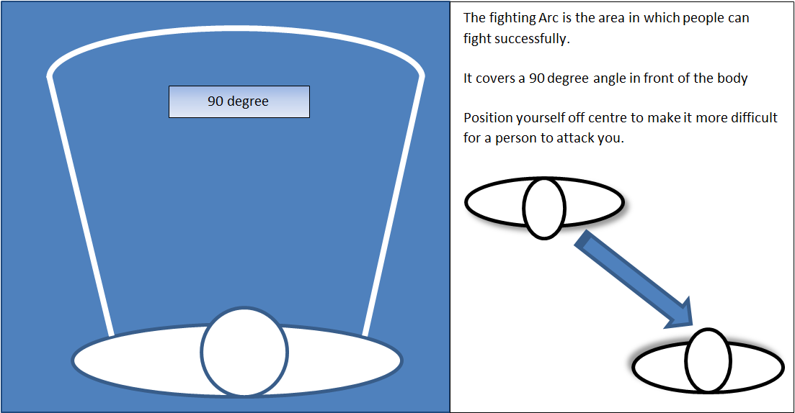
The designated searcher should consider the following guidance as it gives a structured, systematic approach to searching;
Imagine the body split into 5 areas (see Fig C)
Figure C. Sectors of the body
Sector 4
Sector 5
Sector 3
Sector 2
Sector 1
Other considerations.
Your College may operate a challenge policy rather than a search policy. Any student who is believed to be carrying a weapon and is challenged but refuses to be searched is non-compliant and you should consider;
- How accurate is the information that they have a weapon? see Toolkit A
- What does the risk to other students, staff, the student (consider self-harm) or the community look like?
- Does the information you have and the perceived risk require you to contact the police as a matter of urgency?
- Is there scope to ask the student to accompany members of staff to a quiet room where they can reflect and be given time to consider their actions, with a view to handing the weapon over safely.
- Should the young person be directed off site and the police contacted on 101 – consider the Threat, Harm, Opportunity and Risk around the student. Consider the effect on the student, other students, your staff and local community before directing them off.
- This should be recorded.
- Ensure the safety of the college site.

Training offer (2020/2021)
Excel is commissioned to deliver training to staff around a safer approach to searching. This will be an accredited train the trainer model.
This will give staff the confidence to search and do so safely.

Aims (Purpose)
That by the end of the event participants
- Will be aware of strategies aimed at reducing the threat of knives gaining entry to the school.
Objectives (Key Points)
That by the end of the presentation participants will:
- Be able to use the risk assessment model used during the event.
- Have identified the existing locally appropriate risk mitigation strategies.
- Have observed scanning and searching demonstrations and will practised these and demonstrated an appropriate level of competence with each.
- Will be able to outline Reasonable Grounds
The training is being coordinated by the GM VRU.

Case Study (1)
- RM is 16 years old and attends college on a mechanics course.
- RM’s Mum has various illnesses and is bed bound, Dad is not involved, and RM has not seen Dad since being around 5 years old.
- RM and family are Italian Somalian and Mum speaks little English.
- Older brother is currently in prison for TWOC and drug offences.
- RM has been known to Children’s Services for most of their life.
- There was previous domestic violence in the home which RM witnessed.
- RM has undiagnosed learning needs and did not achieve any GCSE’s. College are now working to support him to achieve this.
- RM had poor behaviour in school and did not engage well. RM often went missing from education with peers in his year.
- Mum began to vocalise concerns for RMs well-being stating that she felt RM was fearful of people in the community.
- Additionally, to this Mum shared he was climbing out the windows late at night and young people were waiting outside the house
- RM’s behaviour began to deteriorate and RM was not attending college despite speaking positively about it previously.
- College place RM on a reduced timetable which means RM began to spend more time in the community.
- Whilst out in the community RM’s best friend is arrested, the house of the best friend is conducted, and a gun is found.
- Following this incident RM’s home is searched and police find money and a large amount of cannabis
There is a risk that RM is going to be criminalised.
Where can intervention come to reduce the risk??
Spending less time at College – the outcome likely to be poor.
What could happen to RM?
The risk is that RM has been groomed and exploited to be involved in an OCG (Organised Crime Group) and will become criminalised. Young people that are exploited face trauma and as a result could end up not only criminalised but physically hurt/ killed or have PTSD and other mental health issues.

Case Study (2)
- OS is 16 years old and attends college that is close to where his friends live.
- OS did not attend school frequently, and there was limited information at the point of transition.
- OS struggles to get in college on time, but college work hard to engage him on this.
- Mum works hard to provide for the family and taking care of OS’s younger siblings.
- Home visits are carried out throughout academic year to try to encourage engagement
- OS discloses to his project worker (outside of college) that he previously sold drugs for an OCG when he was 13 years old.
- Information is shared with the police, and MASH referral put in. MASH team at this time decide there is no significant harm to the family.
- Very little information is shared at this point regarding what risk factors need to be considered and how wide the risk is
- Project worker and college continue to work together to gather information and safeguard.
- Safety planning work completed with OS.
- OS and younger brother are targeted in local area by a well-known gang.
- These threats begin to target the family home and another MASH referral made.
- OS begins hard to engage in both 1-1 sessions with project worker and college.
- Information is gathered on peers and found OS is linked to other known young people that are involved in criminal behaviour.
- OS has been linked to criminal behaviour involving assault, shootings in the area, car thefts and drugs
- OS has also been the victim of attempts on life involving firearms and cars, family home has been targeted and damaged
What could happen to OS?
OS has been criminalised for offences that have taken place. It is clear from OS earlier disclosure that he has been a victim of exploitation. OS has had threat to life and this could ultimately lead to death.
What can professionals do?
How can we ensure that education are notified at the earliest opportunity when any young people are at risk especially when they are educated out of area?
What interventions can be implemented when the risk is so high for YP at college and in his home environment?

Tips for responding to exploitation
- Awareness raising about exploitation and knife crime with all college staff and students.
- Provide students with safe spaces where they can talk about experiences. This could be groups, tutor sessions, pastoral one to ones.
- Have mentors within school for young people, this could be staff or peer support.
- Work with all staff in College so that they can recognise signs as well as knowing and understanding the risk factors and indicators
- Exploitation is a contextual safeguarding problem- think about who else you can work with, parents, police, social care.
- Work with the Police to share the information so that everyone knows what, who and where the risks are.
- College / CSC to advocate for the student, learn about the student, recognise their past trauma, and know who they are.
- The advocate/mentor is required to attend all multi agency meetings and will normally be a designated person to act on behalf of HE College.
- Share information and understand the need to build good relationships between all agencies. There are good interventions where there are good relationships.
- Recognition of the role by SMT / senior staff in providing supervision and training as required, and reference to it in Safeguarding and Mental Health policies would add value.
- Many colleges have student liaison, pastoral workers assigned to delivering this role. Safeguarding is however everyone’s responsibility and it is important to support this role.
- The Senior Safeguarding Officer should make a referral to Children’s Services, focussing on the child being exploited which may lead to a S47 enquiry. This would reduce the risk inside and outside of the school.
- LA make a decision as to whether to utilise the National Referral Mechanism
- Most importantly build relationships with the student. Young people that are facing trauma will often push professionals away.
- Consider training/workshops for all staff about how to have difficult conversations.
- Advocate for the young person, make sure professionals are asking why things are happening?
- Ensure the young person’s voice is shared and heard.
- Remember the student is the victim.
BUILD A RELATIONSHIP WITH THE STUDENT / KEEP AN EYE ON THE STUDENT / KEEP THEM IN A SAFE PLACE (COLLEGE)

Resources
Child Criminal Exploitation - Identification, Understanding CCE and Supporting Children and Families
National Children’s Bureau website
Home Office toolkit
Children’s Society CCE toolkit
Contextual Safeguarding network

